**Creating Data Types**

*The purpose of this assignment is to give you practice creating data types. The first exercise involves an immutable data type; the second exercise considers a mutable data type.*

1. **Color data type.** Write a data type ColorHSB.java that represents a color in *hue–saturation–brightness (HSB) format*, along with a sample client. The HSB color format is widely used in color pickers.

**HSB = (2400 ,100%, 100%)**

A color in HSB format is composed of three components:

* + The *hue* is an integer between 0 and 359. It represents a pure color on the color wheel, with 0° for red, 120° for green, and 240° for blue.
  + The *saturation* is an integer between 0 and 100. It represents the purity of the hue.
  + The *brightness* is an integer between 0 and 100. It represents the percentage of white that is mixed with the hue.

Implement the following public API:

**public class ColorHSB {**

// Creates a color with hue h, saturation s, and brightness b.

**public ColorHSB(int h, int s, int b)**

// Returns a string representation of this color, using the format (h, s, b).

**public String toString()**

// Is this color a shade of gray?

**public boolean isGrayscale()**

// Returns the squared distance between the two colors.

**public int distanceSquaredTo(ColorHSB that)**

// Sample client (see below).

**public static void main(String[] args)**

**}**

Here is some more information about the required behavior:

* + *Corner cases.* Throw an IllegalArgumentException in the constructor if any component is outside its prescribed range (0 to 359 for the hue, 0 to 100 for the saturation and brightness); throw an IllegalArgumentException in distanceSquaredTo() if its argument is null.
  + *String representation.* Return a string composed of the integers for hue, saturation, and brightness (in that order), separated by commas, and enclosed in parentheses. An example is (26, 85, 96).
  + *Grayscale.* A color in HSB format is a shade of gray if either its saturation or brightness component is 0% (or both).
  + *Distance.* The squared distance between two colors (h1,s1,b1) and (h2,s2,b2) is defined to be

min{(h1−h2)2,(360−|h1−h2|)2}+(s1−s2)2+(b1−b2)2

For example, the squared distance between (350, 100, 45) and (0, 100, 50) is 102+02+52=125102+02+52=125.

* + *Sample client.* The main() method should take three integer command-line arguments *h*, *s*, and *b*; read a list of pre-defined colors from standard input; and print to standard output the pre-defined color that is closest to (h,s,b).
    - *Input specification.* The input from standard input consists of a sequence of one or more lines. Each line contains a string (the name of a pre-defined color) and three integers (its hue, saturation, and brightness components), separated by whitespace. The data files [web.txt](https://coursera.cs.princeton.edu/introcs/assignments/oop2/files/web.txt) and [wiki.txt](https://coursera.cs.princeton.edu/introcs/assignments/oop2/files/wiki.txt) are in the specified format.

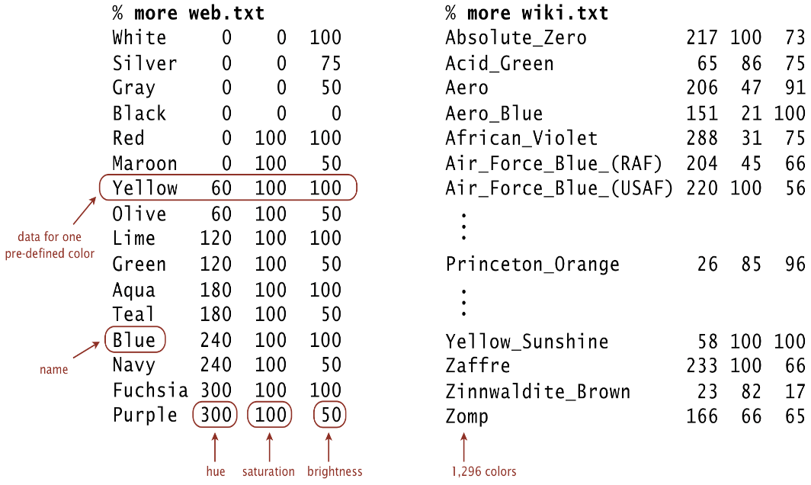

* + - *Output specification.* The output to standard output consists of one line: the name of the nearest pre-defined color and the string representation of that color, separated by whitespace.

~/Desktop/oop2> java-introcs ColorHSB 25 84 97 < web.txt

Red (0, 100, 100)

~/Desktop/oop2> java-introcs ColorHSB 350 100 45 < web.txt

Maroon (0, 100, 50)

~/Desktop/oop2> java-introcs ColorHSB 25 84 97 < wiki.txt

Princeton_Orange (26, 85, 96)

1. **Clock data type.** Write a data type Clock.java that represents time on a 24-hour clock, such as 00:00, 13:30, or 23:59. Time is measured in *hours* (00–23) and *minutes* (00–59). To do so, implement the following public API:

**public class Clock {**

// Creates a clock whose initial time is h hours and m minutes.

**public Clock(int h, int m)**

// Creates a clock whose initial time is specified as a string, using the format HH:MM.

**public Clock(String s)**

// Returns a string representation of this clock, using the format HH:MM.

**public String toString()**

// Is the time on this clock earlier than the time on that one?

**public boolean isEarlierThan(Clock that)**

// Adds 1 minute to the time on this clock.

**public void tic()**

// Adds Δ minutes to the time on this clock.

**public void toc(int delta)**

// Test client (see below).

**public static void main(String[] args)**

**}**

Here is some more information about the required behavior:

* + *Two-argument constructor.* Throw an IllegalArgumentException if either integer argument is outside its prescribed bounds (hours between 0 and 23, minutes between 0 and 59).
  + *One-argument constructor.* The string argument is composed of two digits, followed by a colon, followed by two digits, such as 09:45. Throw an IllegalArgumentException if either the string argument is not in this format or if it does not correspond to a valid time between 00:00 and 23:59.
  + *String representation.* The format is the hours (2 digits), followed by a colon, followed by the minutes (2 digits). Two examples are 00:00 and 23:59.
  + *Ordering.* Times are ordered from 00:00 (earliest) to 23:59 (latest).
  + *Tic.* Add one minute to the current time. For example, one minute after 06:00 is 06:01; one minute after 23:59 is 00:00.
  + *Toc.* Add Δ minutes to the current time. For example, 60 minutes after 12:34 is 13:34. Throw an IllegalArgumentException if Δ is negative.
  + *Test client.* The main() method must call each instance method directly and help verify that they work as prescribed.
  + *Performance.* All instance methods must take constant time.

**Submission.** Submit a .zip file containing ColorHSB.java and Clock.java. You may not call library functions except those in the java.lang (such as Integer.parseInt() and Math.sqrt()). Use only Java features that have already been introduced in the course (e.g., objects but not interfaces).